TOPIC NAME:”TELECOM NETWORK DISRUPTION”(New York based Telecom Company)

# BUSINESS PROBLEM:The problems is to predict the severity of service disruptions on the telecom network.In other words we are supposed to predict if a disturbance occurred or any problems occurred in network or total interruption in connectivity

This will help the company to enhance any connectivity issue or it can provide better connectivity .The accurate predictions of service which can help Telstra serve customers better

Multi class problems It is a mutli classification problem .There can be 3 problems and outcomes

* 0-No Fault
* 1-Minor Fault
* 2-Major Fault

Technogies Used:

Python,Machine learning

Tools Used:Pandas,Matplotlib,Xg Boost

Pandas: Pandas is an open-source Python Library providing high-performance data manipulation and analysis tool using its powerful data structures. The name Pandas is derived from the word Panel Data – an Econometrics from Multidimensional data.

In 2008, developer Wes McKinney started developing pandas when in need of high performance, flexible tool for analysis of data.

Prior to Pandas, Python was majorly used for data munging and preparation. It had very little contribution towards data analysis. Pandas solved this problem. Using Pandas, we can accomplish five typical steps in the processing and analysis of data, regardless of the origin of data — load, prepare, manipulate, model, and analyze.

Python with Pandas is used in a wide range of fields including academic and commercial domains including finance, economics, Statistics, analytics, etc.

Matplotlib: Matplotlib is one of the most popular Python packages used for data visualization. It is a cross-platform library for making 2D plots from data in arrays. Matplotlib is written in Python and makes use of NumPy, the numerical mathematics extension of Python. It provides an object-oriented API that helps in embedding plots in applications using Python GUI toolkits such as PyQt, WxPythonotTkinter. It can be used in Python and IPython shells, Jupyter notebook and web application servers also.

Matplotlib has a procedural interface named the Pylab, which is designed to resemble MATLAB, a proprietary programming language developed by MathWorks. Matplotlib along with NumPy can be considered as the open source equivalent of MATLAB.

Xgboost: **XGBoost** is an optimized distributed gradient boosting library designed to be highly **efficient**, **flexible** and Portable. It implements machine learning algorithms under the Gradient BoostING framework. XGBoost provides a parallel tree boosting (also known as GBDT, GBM) that solve many data science problems in a fast and accurate way

Conclusion: The **telecommunication industry** is going through a transformational phase of development – to acclimatize itself per the new technological and cloud trendAt the very outset, the focus was on the Communication Technology (CT) which marked the first wave of the information era. The second phase was the internet phase which started approximately around the year 2000. The industry realigned itself around horizontal solutions during this phase. It was the time of e-commerce and portals.

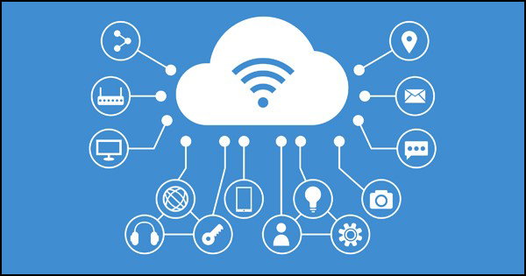

1. Telcos have to decentralize the purchasing and decision power, both internally and externally, because of the essential agile reconfiguration of the cloud.
2. With the availability of new technologies, the variety and quality of services from telecom companies and internet service providers (ISP) are increasing, profit margins are decreasing, and the lines between telecom companies and technology vendors are blurring. Hence, telcos have to take a fresh look at the level of ICT innovation and adapt their organization to digital transformation by creating strong cross-functional interfaces and by seeking tools for maintaining organizational flexibility.
3. With millions of subscribers, a variety of new products, bundled and customized solutions, the operational support services like service configuration, order fulfillment, customer care, and billing are becoming increasingly complex. Hence, the cost of handling these operations require resources and different tools, thus, increasing the financial overhead.
4. Telecommunication providers need to upgrade their IT and connectivity infrastructure and focus on providing data and voice services that are high quality, reliable, and affordable. Security of the networks has become a major priority for the telcos and they are facing challenges with the emergence of new threats that are powered by new technologies. So, a number of operational and technical innovations are needed to meet customer expectations of complete system security from network till the device level.
5. One more challenge waiting in the wings for telcos and ISPs is the impact of Internet of Things (IoT) that is leading to explosive growth in the connected devices. This growth is generating billions and trillions of new data sources and thus, it is expected that this growth will push the data to be handled by networks to zettabytes per year.

**Customer service chatbots**, like CenturyLink’s ‘sales assistant’, **speech and voice services for customers** where they can explore or buy content by speaking, **traffic classification, network optimization and orchestration, and predictive network maintenance**, like AT&T’s self-healing and self-learning hardware that’s powered by artificial intelligence are among some AI applications that are used by the leading players and are among the emerging trends in the telecommunication sector.

**Github code**:

<https://github.com/Preeti-Pundir/preeti2/blob/master/Telstra%20Networs.ipynb>